

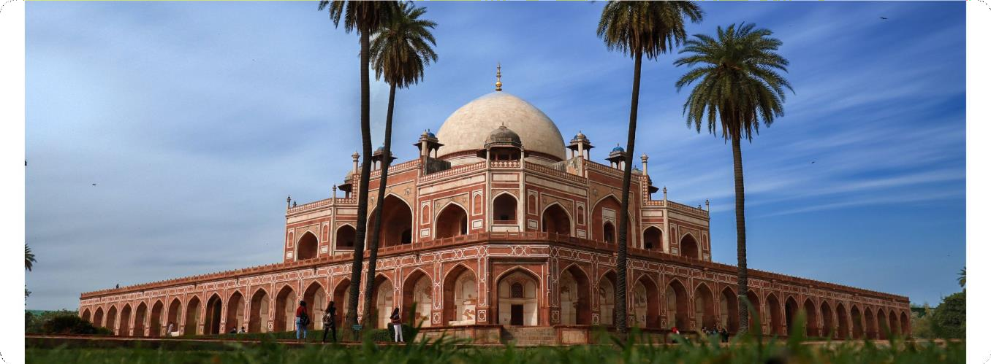
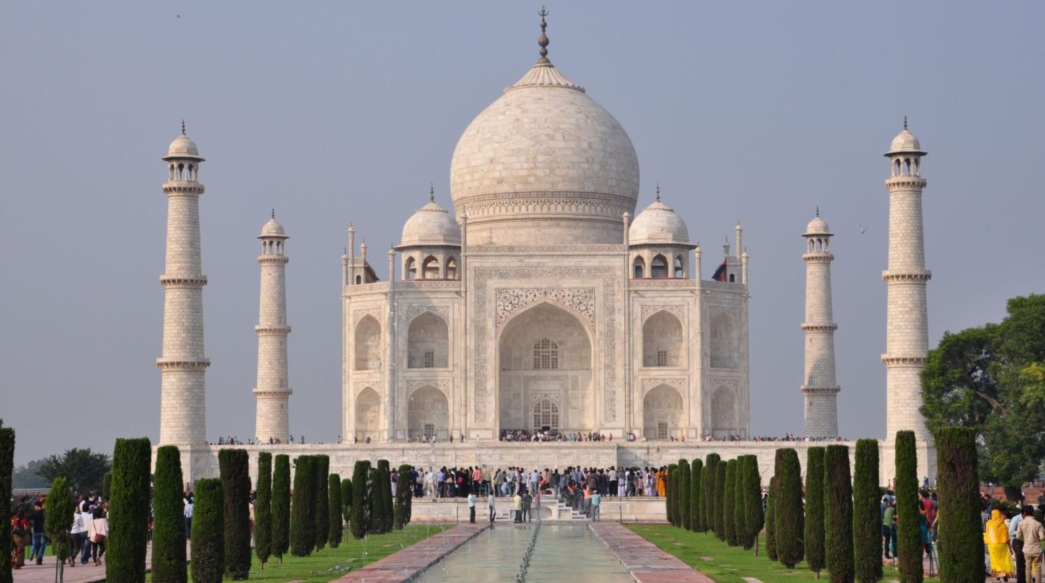

Detailed Itinerary



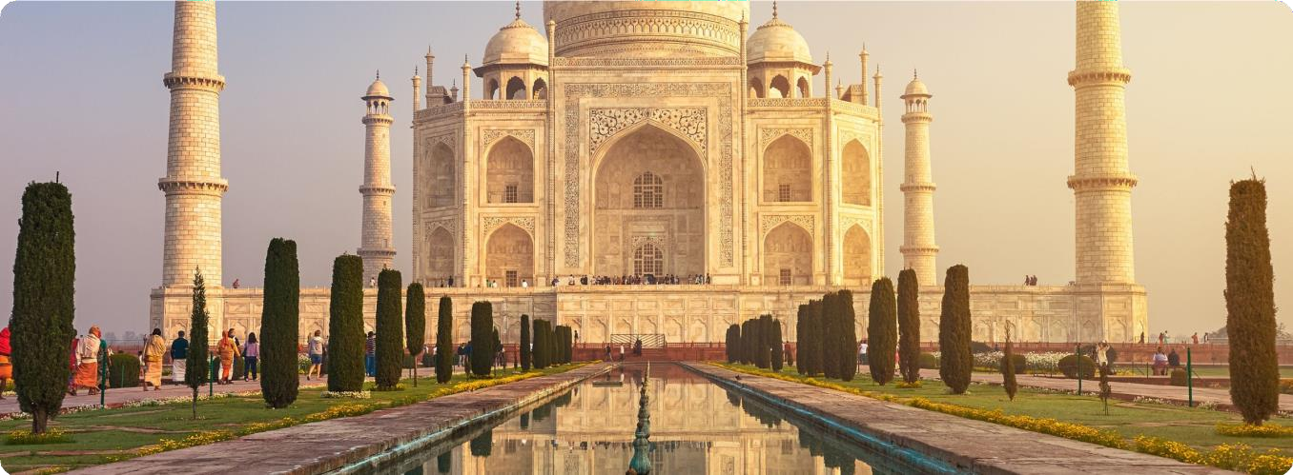


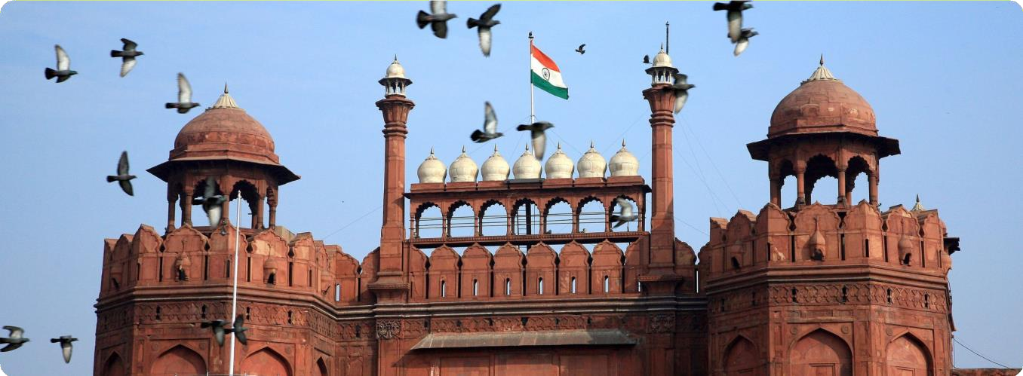

Day 2 | Delhi to Agra

Morning : After breakfast, depart for Agra (about 3-4 hours) .
Afternoon Visit: Upon arrival, visit the Taj Mahal. Spend a few hours exploring this iconic landmark.
Evening:- Visit the Agra Fort, a UNESCO World Heritage Site, and enjoy views of the Taj Mahal from Mehtab Bagh (across the Yamuna River). Overnight: Stay in Agra.

Day 3 | Agra to Delhi

After breakfast, check out from your hotel in Agra and head back to Delhi.
(optionally )Stop at Fatehpur Sikri, a UNESCO World Heritage Site, located about halfway between Agra and Delhi.
Upon arrival, check-in to your hotel and relax for a while.
Visit Qutub Minar, a UNESCO World Heritage Site and the tallest brick minaret in the world. Explore the Iron Pillar and the surrounding archaeological complex.
Optionally, you can also visit Lotus Temple, a Bahá'í House of Worship, famous for its flower-like structure and peaceful atmosphere.
Evenning :Head to Connaught Place, Delhi’s bustling shopping and entertainment hub. Enjoy a stroll, do some shopping, or relax at one of the cafes.
After sightseeing return back to your hotel for an overnight stay .



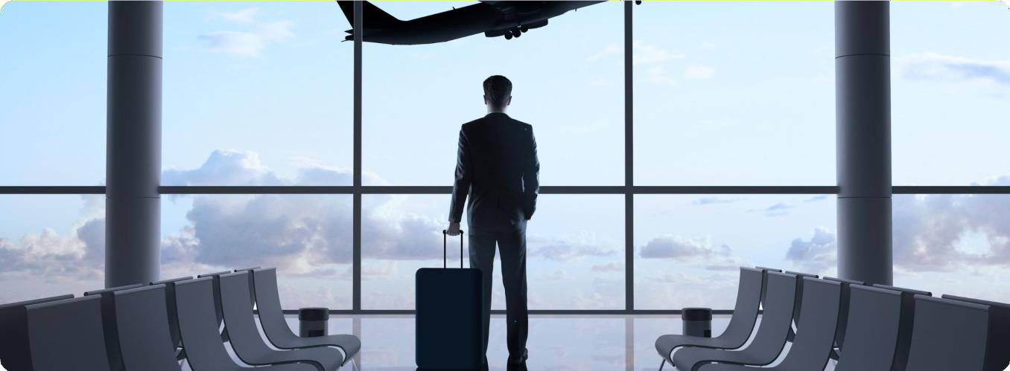



#Inclusions/Exclusions
Exclusions




Terms and Condition

Advance amount is non-refundable if the customer cancels his/her booking due to any reasons.
Identification: Valid government-issued IDs must be presented for verification prior to boarding. Boarding will not be permitted without proper identification
Booking Transfers: Transferring bookings to other individuals is not allowed. Only those listed at the time of confirmation will be permitted to travel.
Refunds: No refunds will be issued for any services or inclusions not utilized by the client.
. Luggage Responsibility: Travelers are responsible for their own luggage and personal belongings. I will not be held liable for any damage or loss during the tour.
confirmation of rooms or activities are subject to avalibility at the time of booking .
Prohibited Activities: Drinking and smoking are strictly prohibited during the tour due to health and safety concerns. Participants should be physically prepared for activities like trekking and camping at high altitudes.
All sightseeing activities are depending on your available time .

Cancellation Policy

Cancellation Policy If cancelled 35 days before the arrival date, a cancellation fee of 30% of the total package cost will apply.
Cancellation Policy If cancelled 35 days before the arrival date, a cancellation fee of 30% of the total package cost will apply. If cancelled 25 days before the arrival date, a cancellation fee of 50% of the total package cost will apply. If cancelled 15 days before the arrival date, a cancellation fee of 80% of the total package cost will apply If cancelled 07 days before the arrival date, a cancellation fee of 100% of the total package cost will apply. If due to reasons beyond our control like riots, flood, accidents or any other natural or man-made calamities, the program of the tour has to be changed or extended, the additional expenditure for the same will have to be paid by the passengers. As if any passengers, has to leave the tour mid-way, due to any reasons like death of relative, or illness or any other reasons, there shall be no refund for the remaining portion of the tour.
If cancelled 25 days before the arrival date, a cancellation fee of 50% of the total package cost will apply. If cancelled 15 days before the arrival date, a cancellation fee of 80% of the total package cost will apply If cancelled 07 days before the arrival date, a cancellation fee of 100% of the total package cost will apply.
If due to reasons beyond our control like riots, flood, accidents or any other natural or man-made calamities, the program of the tour has to be changed or extended, the additional expenditure for the same will have to be paid by the passengers. As if any passengers, has to leave the tour mid-way, due to any reasons like death of relative, or illness or any other reasons, there shall be no refund for the remaining portion of the tour.

